CHARACTERISTICS STUDY OF SIDEBAND POWER AND FREQUENCIES IN AM USING MATLAB
Analog and Digital Communication — MATLAB Experiment
Date of Experiment | 07/10/2026
Performed By | Lokesh A
Register Number | 192512293
1. Experiment Objective
To model an Amplitude Modulation (AM) communication system in MATLAB and study the message signal, carrier signal, AM modulated waveform, demodulated signal, sideband frequencies, and the corresponding carrier and sideband powers.
2. MATLAB Program
clc;
clear;
close all;
% Parameters
Am = 1; % Message amplitude
fm = 500; % Message frequency (Hz)
Ac = 5; % Carrier amplitude
fc = 5000; % Carrier frequency (Hz)
fs = 20*fc; % Sampling frequency
% Time
t = 0:1/fs:4/fm;
% Message signal
m = Am*sin(2*pi*fm*t);
% Carrier signal
c = Ac*sin(2*pi*fc*t);
% Modulation index
mu = Am/Ac;
% AM signal
am = Ac*(1 + mu*sin(2*pi*fm*t)) ...
.* sin(2*pi*fc*t);
% Demodulation using envelope detection
dem = abs(hilbert(am));
dem = dem - mean(dem);
% FFT
N = length(am);
f = linspace(-fs/2, fs/2, N);
AM_FFT = abs(fftshift(fft(am)))/N;
% Sideband frequencies
USB = fc + fm;
LSB = fc - fm;
% Power calculations
Pc = Ac^2/2;
Psb = (mu^2 * Pc)/4;
% Create figure
figure('Name','AM Modulation','NumberTitle','off');
% 1. Message
subplot(3,2,1);
plot(t,m,'LineWidth',1.2);
title('1. Message Signal (Sine)');
xlabel('Time (s)');
ylabel('Amplitude');
grid on;
% 2. Carrier
subplot(3,2,2);
plot(t,c,'LineWidth',1.0);
title('2. Carrier Signal (Sine Wave)');
xlabel('Time (s)');
ylabel('Amplitude');
grid on;
% 3. AM signal
subplot(3,2,3);
plot(t,am,'LineWidth',1.0);
title('3. AM Modulated Signal');
xlabel('Time (s)');
ylabel('Amplitude');
grid on;
% 4. Demodulated signal
subplot(3,2,4);
plot(t,dem,'LineWidth',1.2);
title('4. Demodulated Signal');
xlabel('Time (s)');
ylabel('Amplitude');
grid on;
% 5. Frequency spectrum
subplot(3,2,5);
plot(f,AM_FFT,'LineWidth',1.2);
xlim([fc-3*fm fc+3*fm]);
title('5. Sideband Frequencies (USB & LSB)');
xlabel('Frequency (Hz)');
ylabel('Magnitude');
grid on;
% 6. Power
subplot(3,2,6);
bar([Pc Psb Psb]);
set(gca,'XTickLabel',{'Carrier','USB','LSB'});
title('6. Sideband Power');
ylabel('Power (W)');
grid on;
% Display values
fprintf('\n----- AM PARAMETERS -----\n');
fprintf('Modulation Index = %.2f\n',mu);
fprintf('USB Frequency = %d Hz\n',USB);
fprintf('LSB Frequency = %d Hz\n',LSB);
fprintf('Carrier Power = %.2f W\n',Pc);
fprintf('USB Power = %.3f W\n',Psb);
fprintf('LSB Power = %.3f W\n',Psb);

3. Output
The MATLAB simulation produces the following graphical outputs:
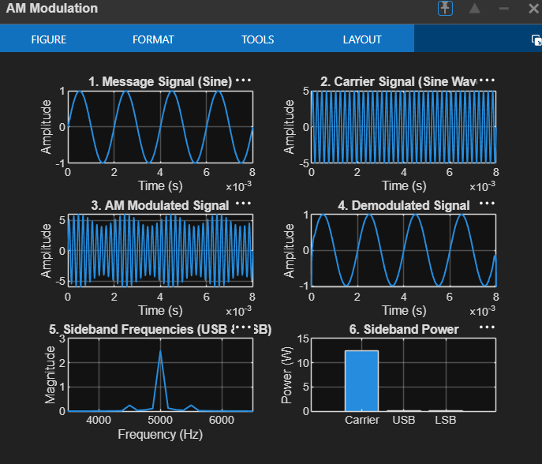
Figure 1. MATLAB graphical outputs for AM signal generation, demodulation, sideband frequencies and power.
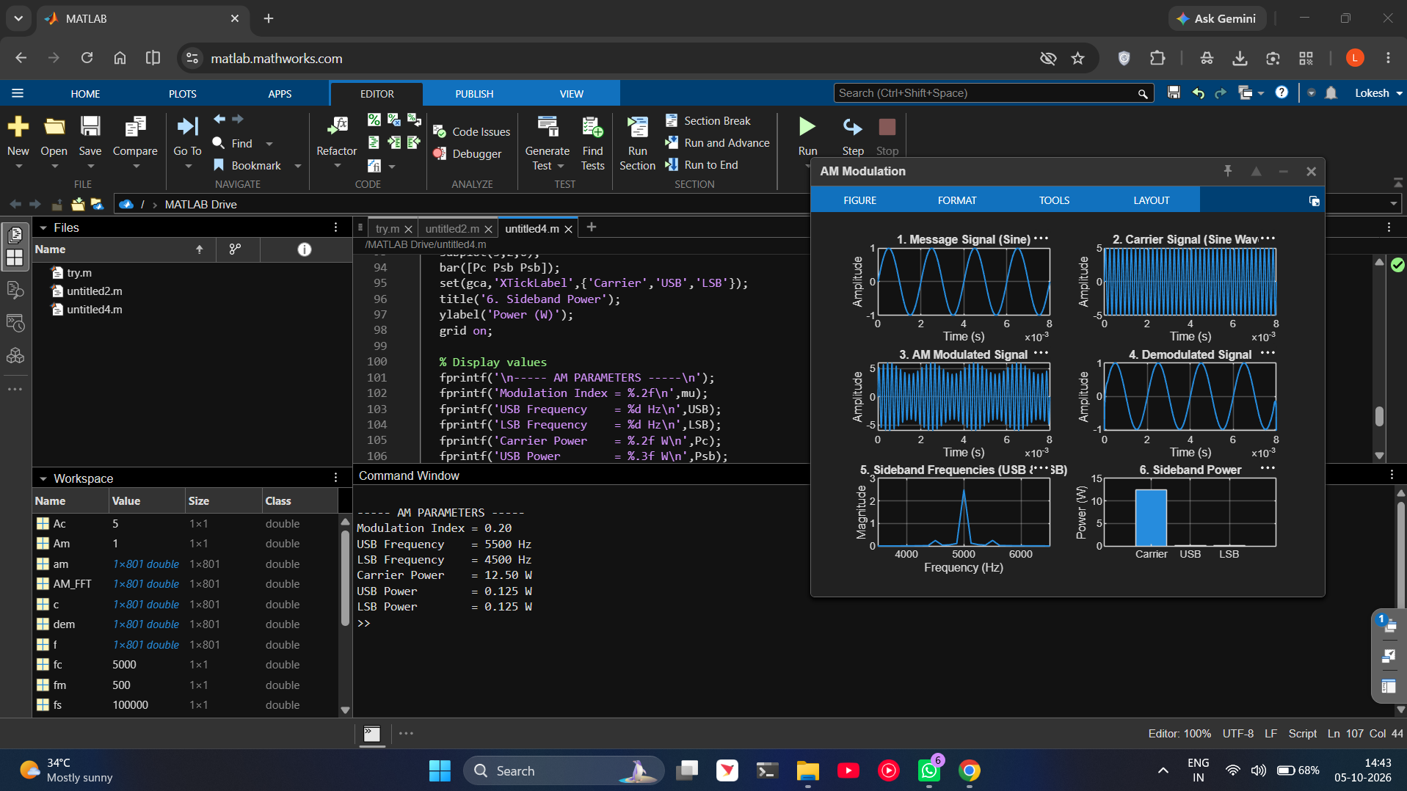
Figure 2. MATLAB workspace and command-window output showing calculated AM parameters.
4. Obtained Results
Parameter | Obtained Value
Message amplitude, Am | 1
Message frequency, fm | 500 Hz
Carrier amplitude, Ac | 5
Carrier frequency, fc | 5000 Hz
Modulation index, μ | 0.20
Percentage modulation | 20%
Lower Sideband (LSB) | 4500 Hz
Carrier frequency | 5000 Hz
Upper Sideband (USB) | 5500 Hz
Carrier power, Pc | 12.50 W
USB power | 0.125 W
LSB power | 0.125 W
5. Applications
- AM broadcasting for transmission of audio information over radio communication channels.
- Medium-wave and short-wave radio communication systems where conventional AM reception is used.
- Long-distance broadcasting and communication systems where a modulated RF carrier is used to carry an information signal.
- Laboratory and educational communication-system analysis, particularly for studying modulation, sidebands, bandwidth and power distribution.

6. Alignment with Analog and Digital Communication
The experiment is directly aligned with the core AM topics of Analog and Digital Communication. The MATLAB model demonstrates the complete relationship between the message signal, carrier, AM waveform, demodulation, sideband frequencies and power distribution.
ADC Topic | Implemented in MATLAB | Evidence in Output
Amplitude Modulation | AM waveform generated using message and carrier signals. | AM Modulated Signal
Modulation Index | μ = Am/Ac is calculated. | Command-window result: μ = 0.20
Sideband Frequencies | USB = fc + fm and LSB = fc − fm. | Frequency-spectrum graph
Power Distribution | Carrier and sideband powers are calculated. | Sideband Power graph
Demodulation | Envelope detection using the Hilbert transform. | Demodulated Signal graph
MATLAB Communication Simulation | Complete AM generation, analysis and recovery. | Combined six-plot output
7. Justification of the Experiment
- The experiment provides a direct simulation of the AM transmitter and receiver signal flow.
- The message and carrier waveforms can be observed independently before modulation, making the modulation process easy to analyze.
- The AM waveform visually demonstrates how the carrier amplitude varies according to the instantaneous message signal.
- The FFT-based spectrum identifies the carrier, upper sideband and lower sideband components, directly demonstrating the frequency-domain characteristics of AM.
- The calculated USB and LSB powers demonstrate how transmitted power is distributed between the carrier and sidebands.
- The demodulated output verifies that the original message information can be recovered from the AM signal.
- The experiment therefore connects theoretical AM equations with observable MATLAB waveforms and numerical results, making it suitable for communication-system analysis and academic demonstration.
8. Conclusion
The characteristics of an AM communication system were successfully modelled and analyzed using MATLAB. The simulation generated the message, carrier and AM signals, recovered the message through demodulation, identified the USB and LSB frequencies, and calculated the carrier and sideband powers. The obtained results verify the expected frequency-domain and power characteristics of conventional AM.

Done by
Lokesh A (192512293)

